Ajith Sylvester

Objective
This experiment aims to study the characteristics of a simple buck converter. The circuit will be operated under continuous current mode (CCM) and open-loop conditions (no feedback). Our main goal is to compare the theoretical results with the experiment results.

Measurement and Waveforms
- Varying Duty Ratio
• Set the switching frequency at 100kHz and RL = 10Ω
• Set the duty ratio D at 50%
• Set the input voltage Vin = 15V

    - When the duty cycle was 50% (D=0.5)

    - The output ripple voltage (AC COUPLING) - 206 mV
    - Inductor Current Ripple (DC COUPLING) - 445*2 = 890 mA
    - Capacitor Current - 9.73*10 = 97.3 )_mV
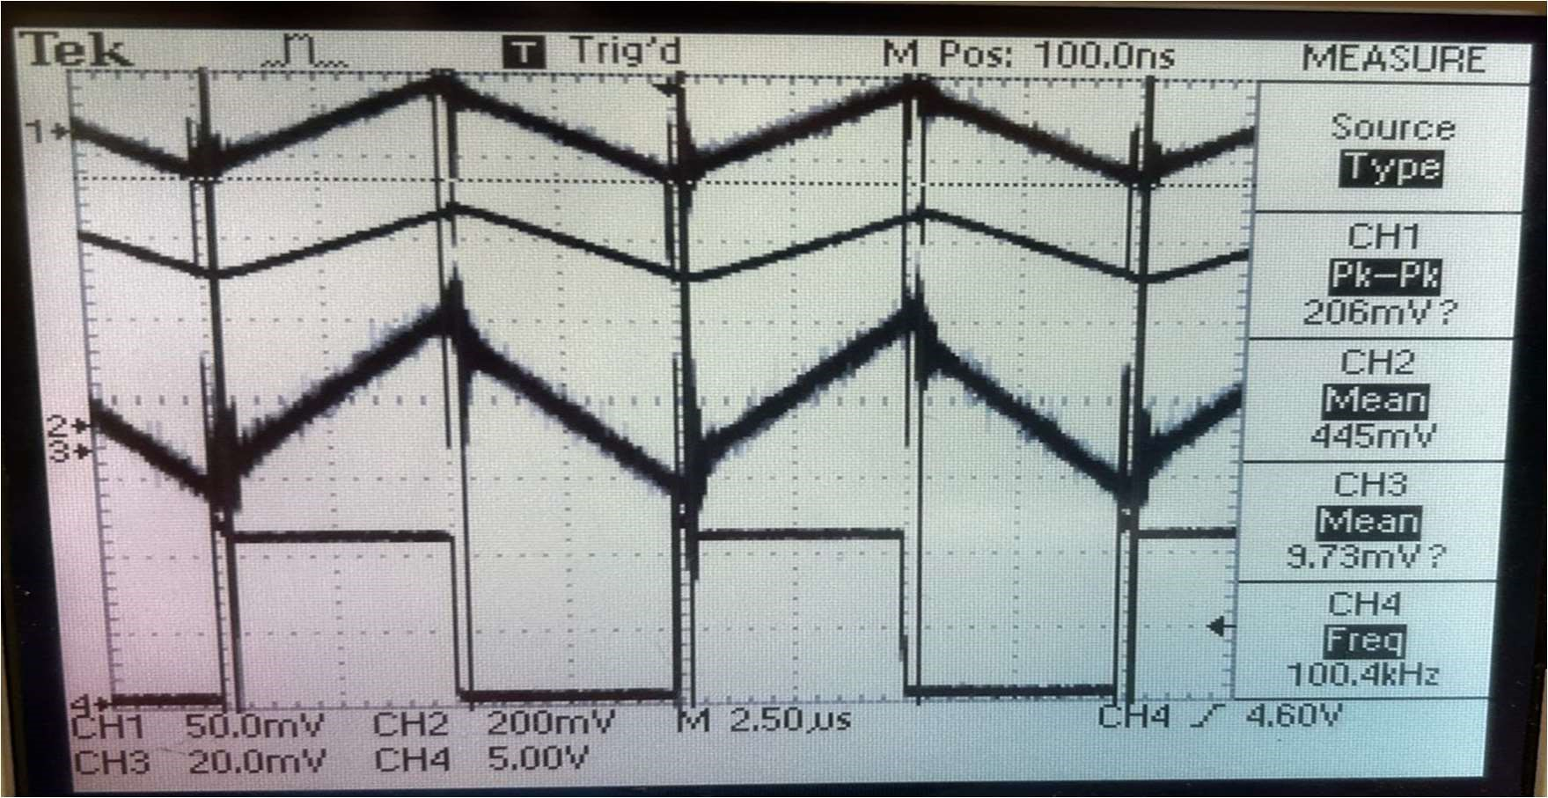
    - PWM – 100.4KHz

Fig 1: output ripple voltage, inductor current, capacitor current, and switch driving
signal (PWM signal)

To calculate theoretical value, use the below formula of Buck Converter
Vout = 𝐷 ∗ 𝑉in -----(1)
Using the above equation,
We know that the
Vin = 15 V
So now D= 0.3, 0.5 and 0.8

Vout = 0.3 *15 = 4.5 V
Vout = 0.5 *15 = 7.5 V
Vout = 0.8 *15 = 12 V

SI. No | Duty Cycle | Calculated Average Output Voltage | Average Output Volatge (Practical)
1 | 0.3 | 4.5 | 4.6
2 | 0.5 | 7.5 | 7.6
3 | 0.8 | 12 | 11.6
Table 1: Duty cycle vs Output Voltage (Theoretical and Calculated)

Attach a graph output voltage versus duty ratio using data obtained in section 2.5.1. Also, plot the theoretically calculated results on the same graph. Compare the two plots and comment about how the buck converter works as a variable DC step down transformer.

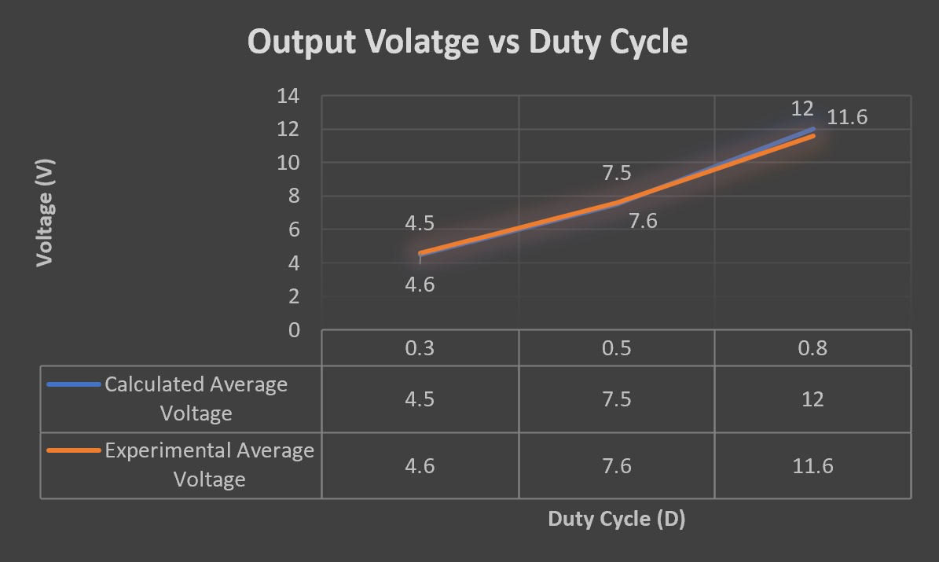

Fig 2: Average Output Voltage V/s Duty Cycle
So, from the above graph and equation, we can see that a Buck converter can be
used as a variable step-down transformer. 15V is stepped down to 12 using duty
cycle = 0.8, and it can be further dropped to 7.5 using duty cycle = 0.5 and
It can be dropped to 4.5 using Duty Cycle = 0.3.

- Varying Frequency:
Plot the peak-peak ripple in the output voltage versus switching frequency using data obtained in section 2.5.2. Plot the theoretical results on the same graph. Compare the two plots. Comment on why you are asked to maintain the average output voltage constant for the three different frequencies.

Before we start calculating theoretical values of the voltage values, we need the
below information which is:
The output capacitor = 680 uF.
Resistance = 10 ohms,
Duty Ratio = 0.5
Output Voltage = 7.6V
L=100uH
Before we compare the theoretical value and the experimental value let’s see how to calculate the output voltage ripple theoretically
We know that,

C*𝑑𝑣/𝑑𝑡 = 𝐼c
Using the above equation, we can derive the voltage ripple equation below.
∆𝑣 = 𝑉o*((1 − 𝐷) / f² ∗ 8 ∗ 𝐿 ∗ 𝐶
Frequency (KHz) | 40 | 60 | 100
Voltage Ripple (mV)Experimental | 600 | 560 | 520
Voltage Ripple (mV) theoretical | 4.38 | 1.79 | 0.72
Table 2: Experimental value and the theoretical value of output voltage ripple vs
different frequency
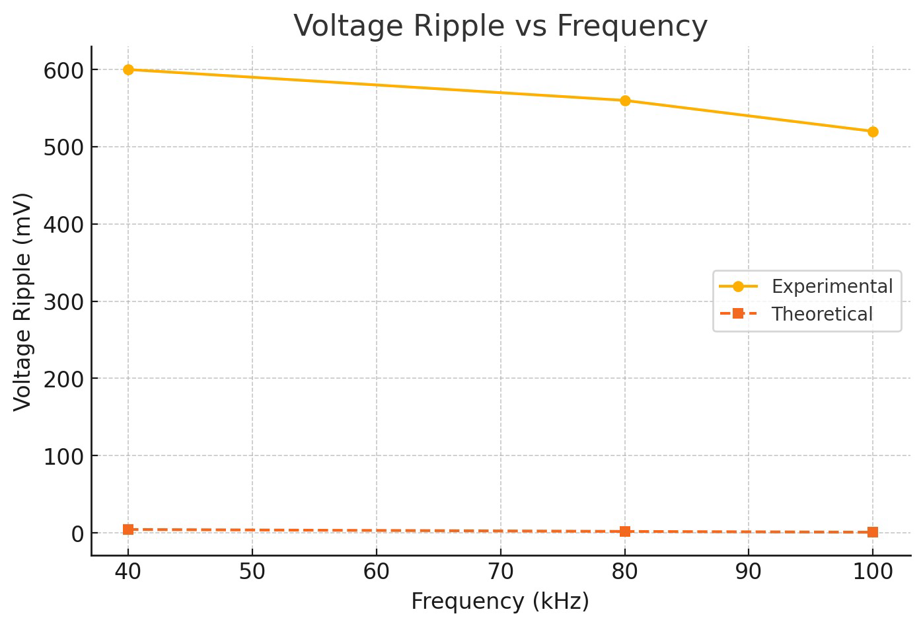
Fig 3: Output Voltage Ripple V/s Frequency

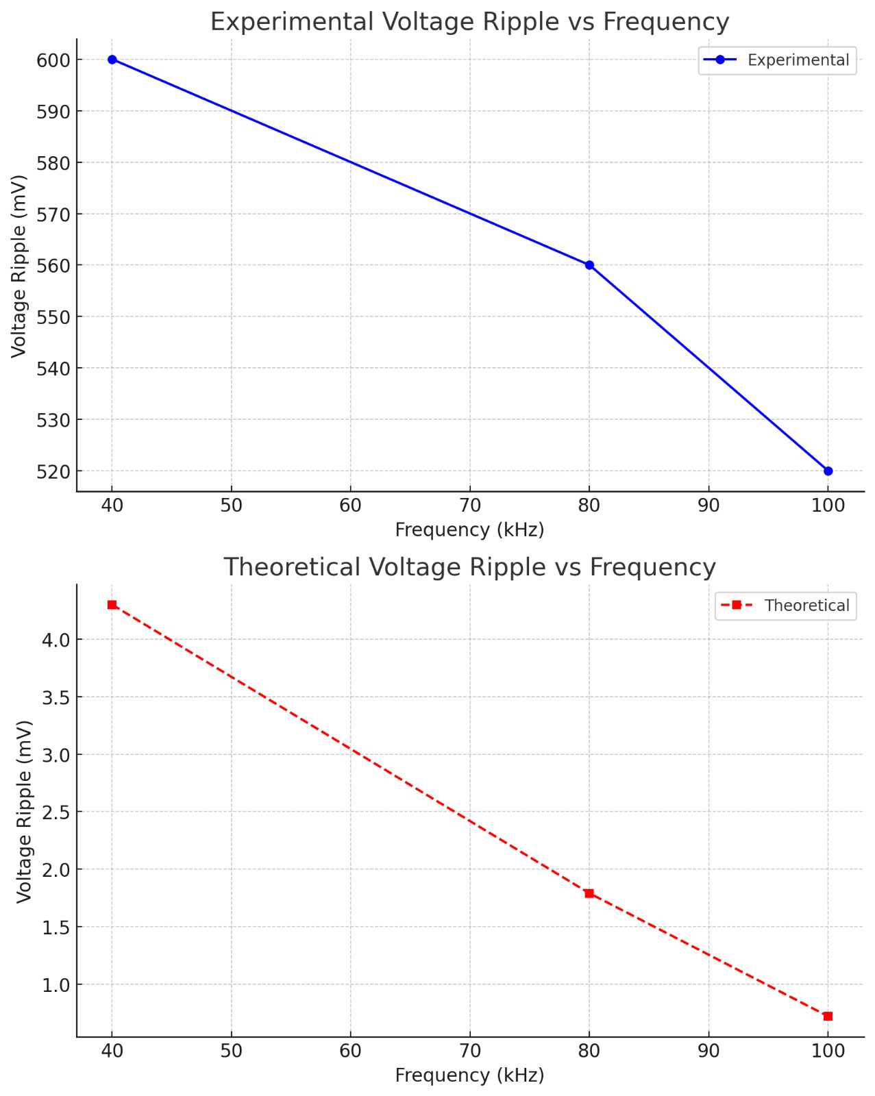
Fig 4: Output Voltage Ripple V/s Frequency on different plots that show the distinctions

We are asked to maintain the output voltage constant so that the only variable will be frequency. This helps us better understand how frequency affects the voltage ripple.
According to the formula above, the output voltage ripple depends upon the Switching Period (T) and is directly dependent on the input frequency. As the frequency increases, we decrease the switching period; hence, the output voltage ripple decreases theoretically. This trend can be seen in the ‘Voltage Ripple Experimental’ column table.

- Varying Load
Attach two captures of the waveforms from section 2.5.3. Compare with the simulation waveforms. Calculate the theoretical load RL when it enters DCM.

We set the frequency at 100 kHz, D = 0.5, and Rload = 10

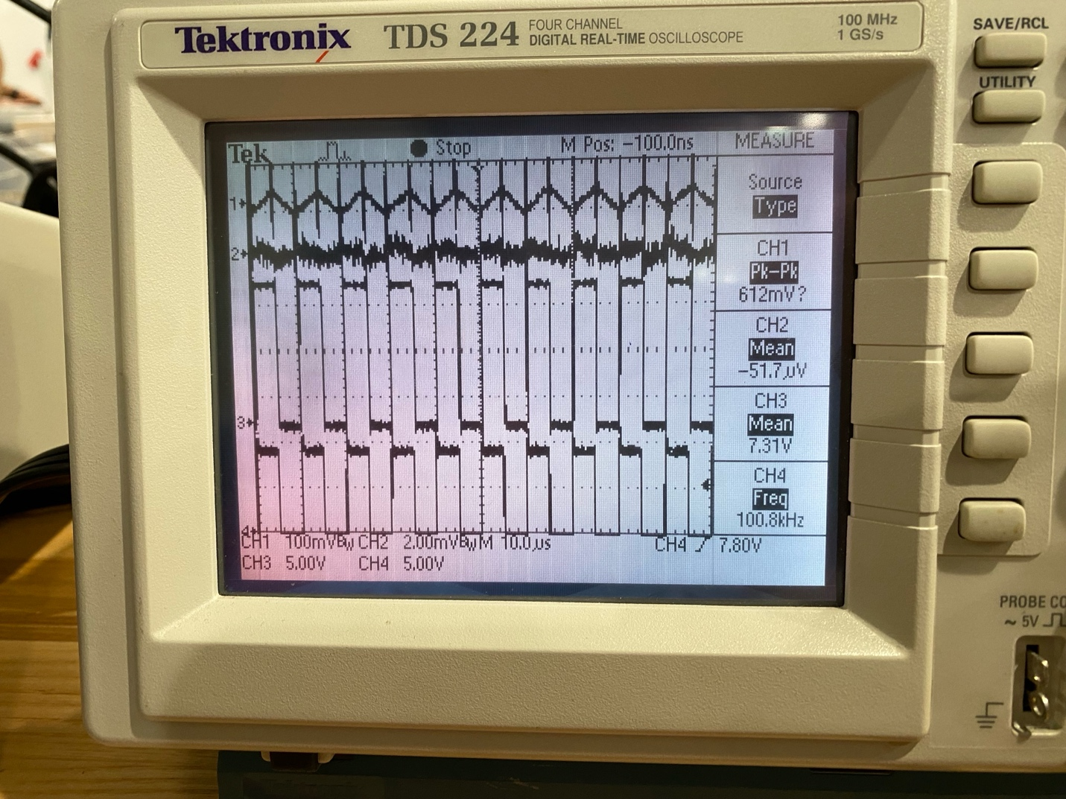

Fig 5: output ripple voltage, MOSFET across voltage, Diode across voltage, and switch driving signal (PWM signal)

Now Replacing the Channel 1 measurement to Inductor current and
increasing the load until the buck converter enters DCM mode we get the
below graph.

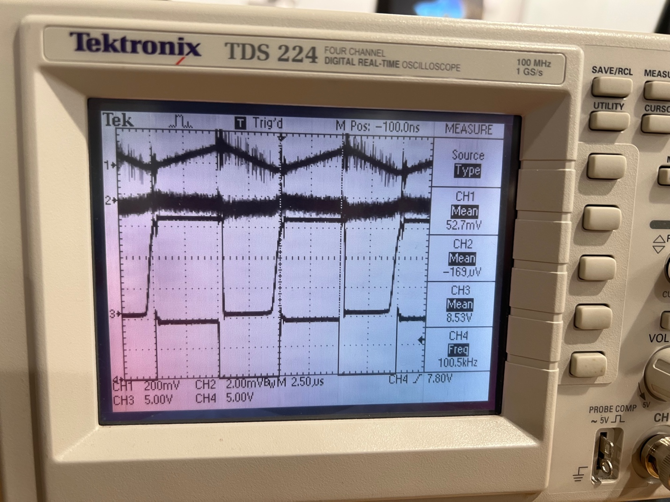
Fig 6: DCM Inductor current, mosfet across voltage, Diode across voltage, and switch driving signal(PWN signal)

Now, to calculate the Rload before the converter enters DCM mode, we can use the
below formula 𝐿critical = 𝑅 ∗ (T/2) * (1 − 𝐷 )
𝑅 = (𝐿critical ∗ 2) / (𝑇 ∗ (1 − 𝐷 )
In equation 3, substitute Lcritical as 100 uH and D1 as 0.5 and T as 10 us
We get,
Theoretical RLoad = 40 ohm Theoretical Value of R Load.
DCM Average inductor current from the experiment was 104mA(Applying the conversion factor of X2 to 52mV).
Rload value after disconnecting the load was 57 ohm.

- Determining Efficiency :
Plot efficiency versus frequency using the data obtained in section 2.5.4. Comment on the results you obtain

Efficiency Calculations for Various Frequencies
Frequency | Input Voltage | Input Current | Input Power | Output Voltage | Output Current | Output Power | Efficiency (%)
40 kHz | 15V | 0.69A | 10.364W | 7.63V | 1.1A | 8.393W | 80.9%
60 kHz | 15V | 0.69A | 10.47W | 6.97V | 0.98A | 6.8306W | 65.23%
100 kHz | 15V | 0.71A | 10.65W | 6.95V | 0.82A | 5.699W | 53.55%

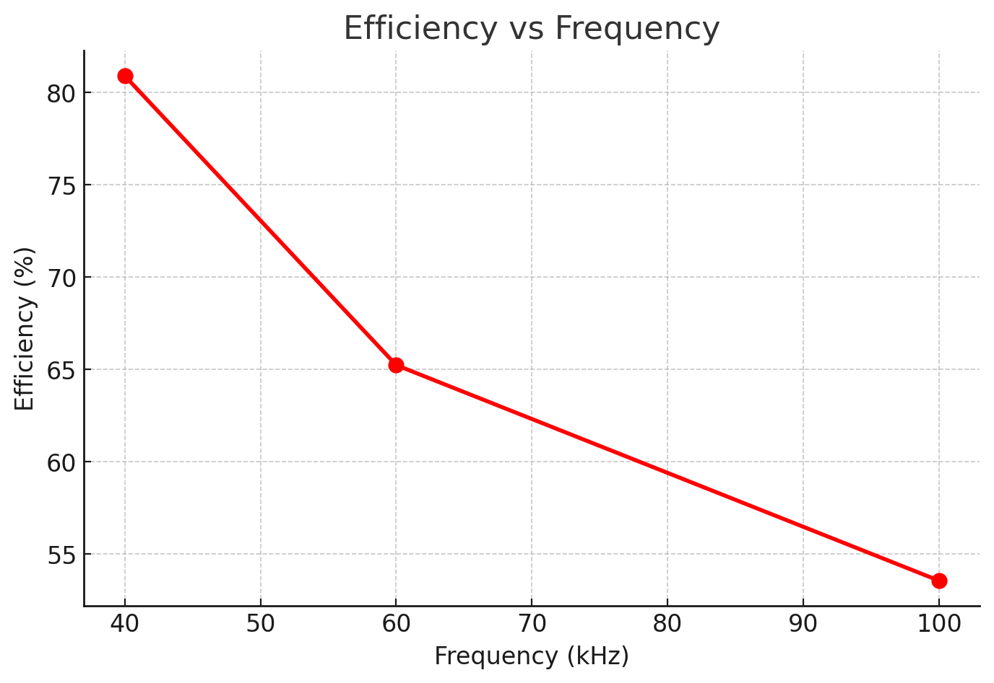
Fig 7: Efficiency vs Frequency

Efficiency decreases as frequency rises. This is primarily due to switching losses; as frequency increases, the switch turns on and off more often, which leads to enhanced switching losses. There might be some losses due to the internal resistances of the components used, which can also contribute to the decrease in efficiency.

